How To Measure Your Pet

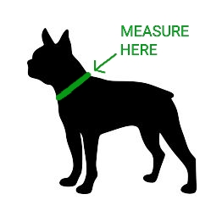

The best way to measure your pet is using a soft sewing tape measure. If you do not have one, you can use a piece of string and a rigid tape measure or ruler.
Measure where your pet’s collar would naturally rest.
Wrap the tape measure or string around your pet’s neck so it is snug but not constricting. Do not leave any space between the tape measure and neck, we will adjust our sizing to allow for the necessary space.

